EXPERIMENT: Depth First Search
Aim:
To implement the Depth First Search (DFS) algorithm using Python to traverse a graph.

Objectives:
- To understand the working principle of Depth First Search algorithm.
- To implement DFS traversal using recursion.
- To explore graph nodes by going deep into each branch before backtracking.
- To maintain a list of visited nodes to avoid repetition.
- To display the order of nodes visited during traversal.

Algorithm: Depth First Search (DFS)
Step 1: Start the program.
Step 2: Create a graph using an adjacency list.
Step 3: Initialize an empty visited list.
Step 4: Select the starting node and mark it as visited.
Step 5: Display the current node.
Step 6: Visit an unvisited adjacent node recursively.
Step 7: Continue the process until all reachable nodes are visited.
Step 8: Display the DFS traversal order.
Step 9: Stop the program.

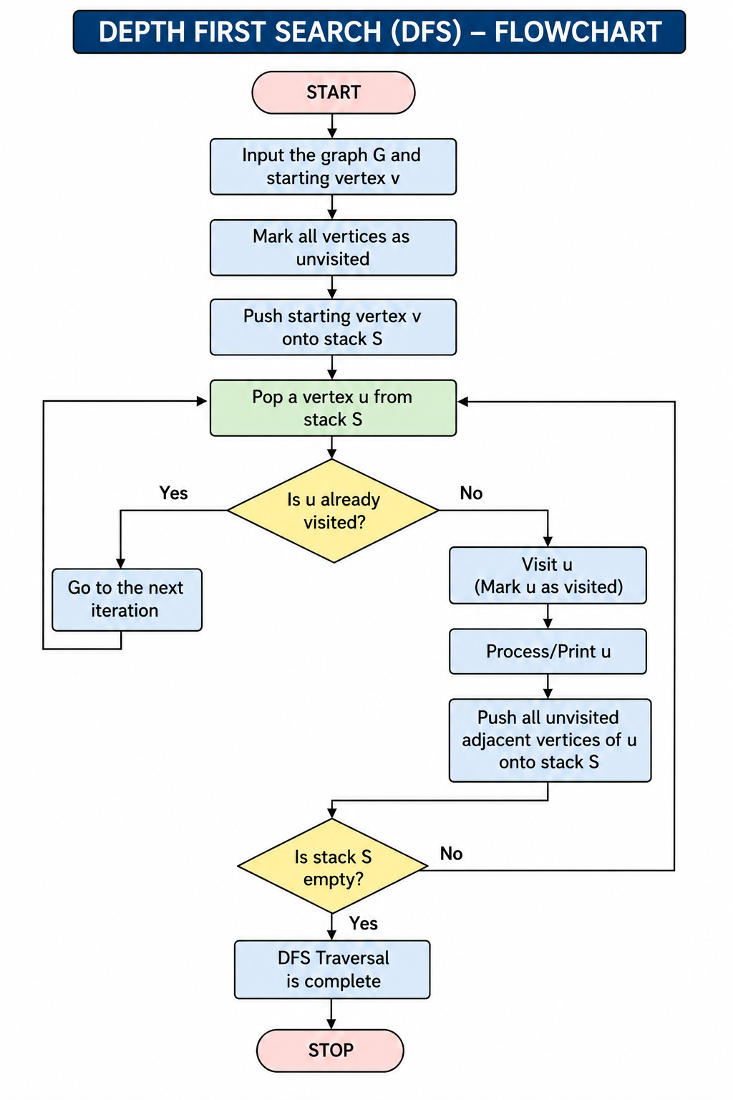
Source Code
# Depth First Search (DFS) Implementation

# Graph representation
graph = {
'A': ['B', 'C'],
'B': ['D', 'E'],
'C': ['F', 'G'],
'D': [],
'E': [],
'F': [],
'G': []
}

# DFS Function
def dfs(node, visited):

if node not in visited:
print(node, end=" ")
visited.append(node)

# Visit adjacent nodes
for neighbour in graph[node]:
dfs(neighbour, visited)

# Main program
visited = []

print("DFS Traversal:")
dfs('A', visited)

OUTPUT
